**1.**

import pandas as pd

data = {

    'DEPARTMENT_ID': [10, 20, 30, 40, 50, 60, 70, 80, 90, 100, 110, 120, 130, 140, 150, 160, 170, 180, 190, 200, 210, 220, 230, 240, 250, 260, 270],

    'DEPARTMENT_NAME': ['Administration', 'Marketing', 'Purchasing', 'Human Resources', 'Shipping', 'IT', 'Public Relations', 'Sales', 'Executive', 'Finance', 'Accounting', 'Treasury', 'Corporate Tax', 'Control And Credit', 'Shareholder Services', 'Benefits', 'Manufacturing', 'Construction', 'Contracting', 'Operations', 'IT Support', 'NOC', 'IT Helpdesk', 'Government Sales', 'Retail Sales', 'Recruiting', 'Payroll'],

    'MANAGER_ID': [200, 201, 114, 203, 121, 103, 204, 145, 100, 108, 205, 0, 0, 0, 0, 0, 0, 0, 0, 0, 0, 0, 0, 0, 0, 0, 0],

    'LOCATION_ID': [1700, 1800, 1700, 2400, 1500, 1400, 2700, 2500, 1700, 1700, 1700, 1700, 1700, 1700, 1700, 1700, 1700, 1700, 1700, 1700, 1700, 1700, 1700, 1700, 1700, 1700, 1700]

}

df = pd.DataFrame(data)

distinct_department_ids = df['DEPARTMENT_ID'].unique()

print("Distinct department IDs:")

print(distinct_department_ids)

output: Distinct department IDs:

[ 10 20 30 40 50 60 70 80 90 100 110 120 130 140 150 160 170 180

190 200 210 220 230 240 250 260 270]

**2.**

import pandas as pd

# Sample data

data = {

    'EMPLOYEE_ID': [102, 101, 101, 201, 114, 122, 200, 176, 176, 200],

    'START_DATE': ['2001-01-13', '1997-09-21', '2001-10-28', '2004-02-17', '2006-03-24', '2007-01-01', '1995-09-17', '2006-03-24', '2007-01-01', '2002-07-01'],

    'END_DATE': ['2006-07-24', '2001-10-27', '2005-03-15', '2007-12-19', '2007-12-31', '2007-12-31', '2001-06-17', '2006-12-31', '2007-12-31', '2006-12-31'],

    'JOB_ID': ['IT_PROG', 'AC_ACCOUNT', 'AC_MGR', 'MK_REP', 'ST_CLERK', 'ST_CLERK', 'AD_ASST', 'SA_REP', 'SA_MAN', 'AC_ACCOUNT'],

    'DEPARTMENT_ID': [60, 110, 110, 20, 50, 50, 90, 80, 80, 90]

}

# Creating DataFrame

df = pd.DataFrame(data)

# Converting START_DATE and END_DATE to datetime objects

df['START_DATE'] = pd.to_datetime(df['START_DATE'])

df['END_DATE'] = pd.to_datetime(df['END_DATE'])

# Grouping by EMPLOYEE_ID and counting the number of unique JOB_IDs

job_counts = df.groupby('EMPLOYEE_ID')['JOB_ID'].nunique()

# Filtering employees who did two or more jobs in the past

employees_with_multiple_jobs = job_counts[job_counts >= 2].index

# Displaying the IDs for those employees

print("Employees who did two or more jobs in the past:")

print(employees_with_multiple_jobs)

output: Employees who did two or more jobs in the past:

Int64Index([101, 176, 200], dtype='int64', name='EMPLOYEE_ID')

**3.**

import pandas as pd

data = {

    'JOB_ID': ['AD_PRES', 'AD_VP', 'AD_ASST', 'FI_MGR', 'FI_ACCOUNT', 'AC_MGR', 'AC_ACCOUNT', 'SA_MAN', 'SA_REP', 'PU_MAN', 'PU_CLERK', 'ST_MAN', 'ST_CLERK', 'SH_CLERK', 'IT_PROG', 'MK_MAN', 'MK_REP', 'HR_REP', 'PR_REP'],

    'JOB_TITLE': ['President', 'Administration Vice President', 'Administration Assistant', 'Finance Manager', 'Accountant', 'Accounting Manager', 'Public Accountant', 'Sales Manager', 'Sales Representative', 'Purchasing Manager', 'Purchasing Clerk', 'Stock Manager', 'Stock Clerk', 'Shipping Clerk', 'Programmer', 'Marketing Manager', 'Marketing Representative', 'Human Resources Representative', 'Public Relations Representative'],

    'MIN_SALARY': [20080, 15000, 3000, 8200, 4200, 8200, 4200, 10000, 6000, 8000, 2500, 5500, 2008, 2500, 4000, 9000, 4000, 4000, 4500],

    'MAX_SALARY': [40000, 30000, 6000, 16000, 9000, 16000, 9000, 20080, 12008, 15000, 5500, 8500, 5000, 5500, 10000, 15000, 9000, 9000, 10500]

}

df = pd.DataFrame(data)

# Sort dataframe by 'JOB_TITLE' column in descending order

df_sorted = df.sort_values(by='JOB_TITLE', ascending=False)

print(df_sorted)

output: JOB_ID JOB_TITLE MIN_SALARY MAX_SALARY

11 ST_MAN Stock Manager 5500 8500

12 ST_CLERK Stock Clerk 2008 5000

13 SH_CLERK Shipping Clerk 2500 5500

8 SA_REP Sales Representative 6000 12008

7 SA_MAN Sales Manager 10000 20080

9 PU_MAN Purchasing Manager 8000 15000

10 PU_CLERK Purchasing Clerk 2500 5500

18 PR_REP Public Relations Representative 4500 10500

6 AC_ACCOUNT Public Accountant 4200 9000

14 IT_PROG Programmer 4000 10000

0 AD_PRES President 20080 40000

16 MK_REP Marketing Representative 4000 9000

15 MK_MAN Marketing Manager 9000 15000

17 HR_REP Human Resources Representative 4000 9000

3 FI_MGR Finance Manager 8200 16000

1 AD_VP Administration Vice President 15000 30000

2 AD_ASST Administration Assistant 3000 6000

5 AC_MGR Accounting Manager 8200 16000

4 FI_ACCOUNT Accountant 4200 9000

**4.**

import pandas as pd

import matplotlib.pyplot as plt

# Sample data (replace this with your actual data)

data = {

    'Date': ['2024-01-01', '2024-01-02', '2024-01-03', '2024-01-04', '2024-01-05'],

    'Close': [100.50, 101.20, 99.80, 102.30, 104.50]

}

# Create a DataFrame from the sample data

df = pd.DataFrame(data)

# Convert the 'Date' column to datetime format

df['Date'] = pd.to_datetime(df['Date'])

# Filter the data for the specific date range

start_date = '2024-01-01'

end_date = '2024-01-05'

filtered_df = df[(df['Date'] >= start_date) & (df['Date'] <= end_date)]

# Plotting the data

plt.figure(figsize=(10, 6))

plt.plot(filtered_df['Date'], filtered_df['Close'], marker='o', linestyle='-')

plt.title('Historical Stock Prices of Alphabet Inc. between {} and {}'.format(start_date, end_date))

plt.xlabel('Date')

plt.ylabel('Stock Price (USD)')

plt.xticks(rotation=45)

plt.grid(True)

plt.tight_layout()

plt.show()

output:

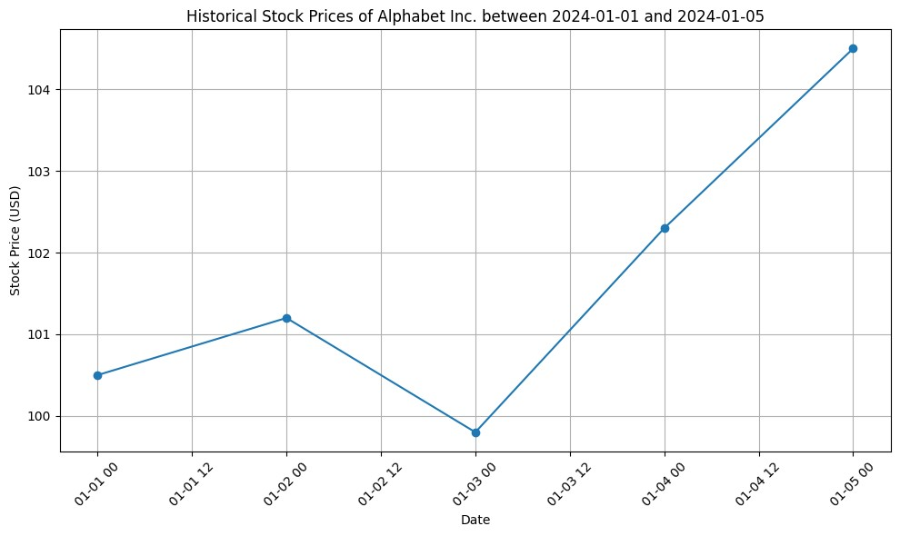

5.

import pandas as pd

import numpy as np

import matplotlib.pyplot as plt

# Generate sample data for demonstration

np.random.seed(0)

dates = pd.date_range(start='2024-01-01', end='2024-03-01', freq='D')

volume = np.random.randint(10000, 50000, size=len(dates))

# Create a DataFrame

df = pd.DataFrame({'Date': dates, 'Volume': volume})

# Create a bar plot of trading volume

plt.figure(figsize=(10, 6))

plt.bar(df['Date'], df['Volume'], color='skyblue')

plt.title('Sample Trading Volume of Alphabet Inc. Stock')

plt.xlabel('Date')

plt.ylabel('Volume')

plt.xticks(rotation=45)

plt.tight_layout()

plt.show()

output:

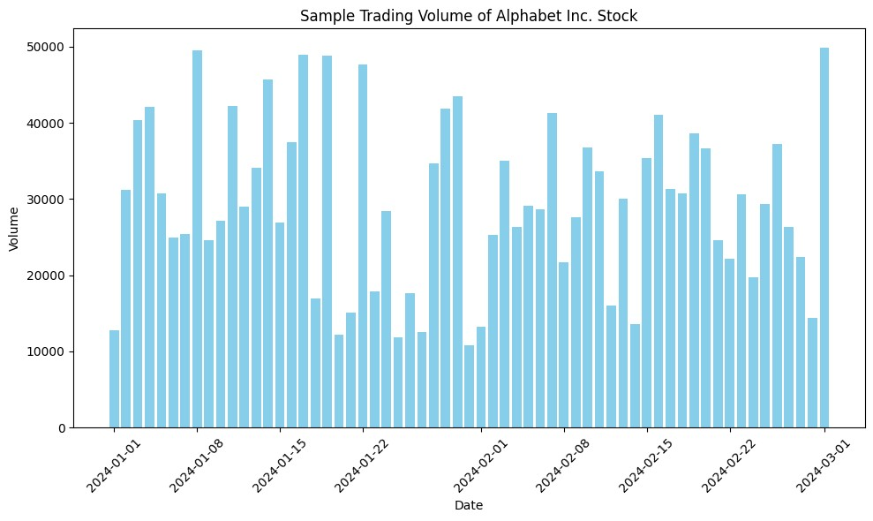

6.

import numpy as np

import matplotlib.pyplot as plt

# Generate synthetic data for demonstration

num_points = 100

dates = np.random.choice(pd.date_range(start='2023-01-01', end='2024-01-01', freq='D'), size=num_points, replace=False)

open_prices = np.random.uniform(low=100, high=200, size=num_points)

high_prices = open_prices + np.random.uniform(low=0, high=20, size=num_points)

low_prices = open_prices - np.random.uniform(low=0, high=20, size=num_points)

close_prices = np.random.uniform(low=100, high=200, size=num_points)

adj_close_prices = np.random.uniform(low=90, high=210, size=num_points)

volumes = np.random.randint(low=10000, high=100000, size=num_points)

# Plot scatter plot of trading volume and closing prices

plt.figure(figsize=(10, 4))

plt.scatter(volumes, close_prices, color='pink', alpha=0.6)

plt.title('Scatter Plot of Trading Volume vs. Closing Prices of Alphabet Inc. (Google)')

plt.xlabel('Volume')

plt.ylabel('Closing Price')

plt.grid(True)

plt.tight_layout()

plt.show()

output:

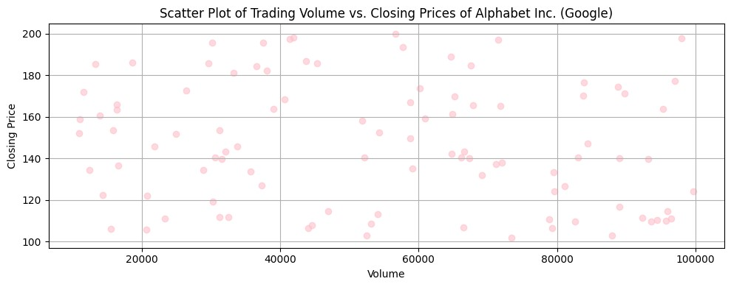

7.

import pandas as pd

# Assuming sales_data is a DataFrame containing sales data

sales_data = {

    'Item': ['A', 'B', 'A', 'B', 'C'],

    'Sale Amount': [100, 150, 200, 250, 300]

}

# Creating DataFrame from sales_data

df = pd.DataFrame(sales_data)

# Creating a Pivot table to find maximum and minimum sale value of items

pivot_max_min_sales = pd.pivot_table(df, values='Sale Amount', index='Item', aggfunc={'Sale Amount': [max, min]})

print("Pivot table for maximum and minimum sale value of items:")

print(pivot_max_min_sales)

output:

Pivot table for maximum and minimum sale value of items:

max min

Item

A 200 100

B 250 150

C 300 300

**8.**

import pandas as pd

# Sample sales data

sales_data = {

    'Date': ['2024-01-01', '2024-01-01', '2024-01-02', '2024-01-02', '2024-01-03'],

    'Item': ['A', 'B', 'A', 'B', 'C'],

    'Units Sold': [10, 15, 20, 25, 30],

    'Sale Amount': [100, 150, 200, 250, 300]

}

# Creating DataFrame from sales_data

df = pd.DataFrame(sales_data)

# Creating a Pivot table to find item wise unit sold

pivot_unit_sold = pd.pivot_table(df, values='Units Sold', index='Item', aggfunc='sum')

print("Pivot table for unit sold of each item:")

print(pivot_unit_sold)

output:

Pivot table for unit sold of each item:

Units Sold

Item

A 30

B 40

C 30

**9**.

import pandas as pd

# Assuming sales_data is your DataFrame containing sales data

# Sample data

sales_data = {

    'Region': ['North', 'North', 'South', 'South', 'East', 'East'],

    'Manager': ['John', 'John', 'Alice', 'Alice', 'Bob', 'Bob'],

    'Salesman': ['Sam', 'Tom', 'Rob', 'Ken', 'Jake', 'Mike'],

    'Sale_Amount': [1000, 1500, 2000, 2500, 1800, 2200]

}

sales_df = pd.DataFrame(sales_data)

# Creating Pivot table

pivot_table = pd.pivot_table(sales_df, index=['Region', 'Manager', 'Salesman'], aggfunc='sum')

print("Pivot Table - Total sale amount region-wise, manager-wise, and salesperson-wise:")

print(pivot_table)

output:

Pivot Table - Total sale amount region-wise, manager-wise, and salesperson-wise:

Sale_Amount

Region Manager Salesman

East Bob Jake 1800

Mike 2200

North John Sam 1000

Tom 1500

South Alice Ken 2500

Rob 2000

**10.**

import pandas as pd

import numpy as np

# Create a DataFrame with random values

np.random.seed(0)  # For reproducibility

data = np.random.randn(10, 4)  # Generating random values

df = pd.DataFrame(data, columns=['A', 'B', 'C', 'D'])

# Define a function to apply color based on values

def color_negative_red(val):

    color = 'red' if val < 0 else 'black'

    return 'color: %s' % color

# Apply styling to the DataFrame

styled_df = df.style.applymap(color_negative_red)

# Display the styled DataFrame

styled_df

output:

11.

import pandas as pd

import numpy as np

# Create a DataFrame with random values

np.random.seed(0)  # for reproducibility

data = np.random.rand(10, 4)

df = pd.DataFrame(data, columns=['A', 'B', 'C', 'D'])

# Randomly convert some values to NaN

nan_indices = np.random.choice(df.size, size=int(df.size * 0.3), replace=False)

df.values.flat[nan_indices] = np.nan

# Define a function to highlight NaN values

def highlight_nan(val):

    if pd.isna(val):

        return 'background-color: yellow'

    else:

        return ''

# Apply the style

styled_df = df.style.applymap(highlight_nan)

# Display the styled DataFrame

styled_df

output:

12.

import pandas as pd

import numpy as np

# Create a DataFrame with random values

np.random.seed(0)  # for reproducibility

data = np.random.rand(10, 4)

df = pd.DataFrame(data, columns=['A', 'B', 'C', 'D'])

# Define a function to set background color to black and font color to yellow

def set_colors(val):

    return 'background-color: black; color: yellow'

# Apply the style

styled_df = df.style.applymap(set_colors)

# Display the styled DataFrame

styled_df

output:

13.

import pandas as pd

import numpy as np

# Create a DataFrame with random values including NaNs

np.random.seed(0)  # for reproducibility

data = np.random.rand(5, 3)

data[np.random.choice([True, False], size=data.shape, p=[0.3, 0.7])] = np.nan

df = pd.DataFrame(data, columns=['A', 'B', 'C'])

# Detect missing values and display True or False

missing_values = df.isna()

print(missing_values)

output:

A B C

0 True True False

1 False False False

2 False False False

3 True False True

4 False False False

**14.**

import pandas as pd

import numpy as np

# Create a DataFrame with random values including NaNs

np.random.seed(0)  # for reproducibility

data = np.random.rand(5, 3)

data[np.random.choice([True, False], size=data.shape, p=[0.3, 0.7])] = np.nan

df = pd.DataFrame(data, columns=['A', 'B', 'C'])

# Display the original DataFrame

print("Original DataFrame:")

print(df)

# Find and replace missing values

df.fillna(df.mean(), inplace=True)

# Display the DataFrame after replacing missing values

print("\nDataFrame after replacing missing values:")

print(df)

**output:**

Original DataFrame:

A B C

0 NaN NaN 0.602763

1 0.544883 0.423655 0.645894

2 0.437587 0.891773 0.963663

3 NaN 0.791725 NaN

4 0.568045 0.925597 0.071036

DataFrame after replacing missing values:

A B C

0 0.516838 0.758187 0.602763

1 0.544883 0.423655 0.645894

2 0.437587 0.891773 0.963663

3 0.516838 0.791725 0.570839

4 0.568045 0.925597 0.071036

**15.**

import pandas as pd

import numpy as np

# Create a DataFrame with random values including NaNs

np.random.seed(0)  # for reproducibility

data = np.random.rand(10, 4)

data[np.random.choice([True, False], size=data.shape, p=[0.3, 0.7])] = np.nan

df = pd.DataFrame(data, columns=['A', 'B', 'C', 'D'])

# Display the original DataFrame

print("Original DataFrame:")

print(df)

# Keep the rows with at least 2 NaN values

df_with_at_least_2_nan = df.dropna(thresh=2)

# Display the DataFrame with at least 2 NaN values

print("\nDataFrame with at least 2 NaN values:")

print(df_with_at_least_2_nan)

**output:**

Original DataFrame:

A B C D

0 0.548814 0.715189 0.602763 NaN

1 0.423655 0.645894 NaN NaN

2 0.963663 0.383442 0.791725 0.528895

3 0.568045 NaN NaN NaN

4 0.020218 NaN 0.778157 NaN

5 NaN NaN 0.461479 NaN

6 NaN 0.639921 0.143353 NaN

7 0.521848 NaN 0.264556 0.774234

8 0.456150 0.568434 0.018790 NaN

9 NaN NaN NaN NaN

DataFrame with at least 2 NaN values:

A B C D

0 0.548814 0.715189 0.602763 NaN

1 0.423655 0.645894 NaN NaN

2 0.963663 0.383442 0.791725 0.528895

4 0.020218 NaN 0.778157 NaN

6 NaN 0.639921 0.143353 NaN

7 0.521848 NaN 0.264556 0.774234

8 0.456150 0.568434 0.018790 NaN

**16.**

import pandas as pd

# Create a sample DataFrame

data = {

    'school code': ['S001', 'S002', 'S001', 'S002', 'S003'],

    'student': ['Alice', 'Bob', 'Charlie', 'David', 'Eve'],

    'grade': [85, 90, 88, 92, 87]

}

df = pd.DataFrame(data)

# Split the DataFrame into groups based on school code

grouped = df.groupby('school code')

# Check the type of GroupBy object

print("Type of GroupBy object:", type(grouped))

# Display the groups

for name, group in grouped:

    print("\nSchool Code:", name)

    print(group)

**output:**

Type of GroupBy object: <class 'pandas.core.groupby.generic.DataFrameGroupBy'>

School Code: S001

school code student grade

0 S001 Alice 85

2 S001 Charlie 88

School Code: S002

school code student grade

1 S002 Bob 90

3 S002 David 92

School Code: S003

school code student grade

4 S003 Eve 87

**17.**

import pandas as pd

# Create a sample DataFrame

data = {

    'school code': ['S001', 'S002', 'S001', 'S002', 'S003'],

    'student': ['Alice', 'Bob', 'Charlie', 'David', 'Eve'],

    'age': [18, 20, 17, 19, 21]

}

df = pd.DataFrame(data)

# Split the DataFrame by school code and calculate mean, min, and max age for each school

result = df.groupby('school code')['age'].agg(['mean', 'min', 'max'])

# Display the result

print(result)

**output:**

mean min max

school code

S001 17.5 17 18

S002 19.5 19 20

S003 21.0 21 21

**18.**

import pandas as pd

# Sample DataFrame

data = {

    'Name': ['Alice', 'Bob', 'Charlie', 'David', 'Emma', 'Frank', 'Grace', 'Henry', 'Ivy', 'Jack'],

    'School Code': ['S001', 'S002', 'S001', 'S002', 'S001', 'S002', 'S001', 'S002', 'S001', 'S002'],

    'Class': [10, 11, 10, 11, 10, 11, 10, 11, 10, 11],

    'Score': [85, 90, 88, 92, 89, 93, 87, 91, 86, 94]

}

df = pd.DataFrame(data)

# Grouping based on 'School Code' and 'Class'

grouped = df.groupby(['School Code', 'Class'])

# Printing the groups

for name, group in grouped:

    print("\nGroup:", name)

    print(group)

output:

Group: ('S001', 10)

Name School Code Class Score

0 Alice S001 10 85

2 Charlie S001 10 88

4 Emma S001 10 89

6 Grace S001 10 87

8 Ivy S001 10 86

Group: ('S002', 11)

Name School Code Class Score

1 Bob S002 11 90

3 David S002 11 92

5 Frank S002 11 93

7 Henry S002 11 91

9 Jack S002 11 94

**19.**

import pandas as pd

# Sample data

data = {

    'country': ['USA', 'Canada', 'UK', 'Germany', 'France'],

    'beer_servings': [200, 220, 180, 250, 190],

    'spirit_servings': [100, 120, 90, 150, 110],

    'wine_servings': [50, 60, 70, 80, 90],

    'total_litres_of_pure_alcohol': [10.5, 11.0, 9.5, 12.0, 10.8]

}

# Create DataFrame

drinks_df = pd.DataFrame(data)

# Display the dimensions or shape of the dataset

print("Dimensions of the World alcohol consumption dataset:")

print(drinks_df.shape)

# Extract the column names from the dataset

column_names = drinks_df.columns

print("\nColumn names of the World alcohol consumption dataset:")

print(column_names)

**output:**

Dimensions of the World alcohol consumption dataset:

(5, 5)

Column names of the World alcohol consumption dataset:

Index(['country', 'beer_servings', 'spirit_servings', 'wine_servings',

'total_litres_of_pure_alcohol'],

dtype='object')

**20.**

import pandas as pd

# Sample DataFrame

data = {'Name': ['John', 'Alice', 'Bob', 'Charlie', 'David','alia'],

        'Age': [25, 30, 35, 40, 45,76]}

df = pd.DataFrame(data)

# Function to find the index of a substring in a column

def find_substring_index(dataframe, column_name, substring):

    return dataframe[dataframe[column_name].str.find(substring) != -1].index.tolist()

# Example usage

substring = 'al'

column_name = 'Name'

indexes = find_substring_index(df, column_name, substring)

if indexes:

    print(f"Indexes of rows containing '{substring}' in column '{column_name}': {indexes}")

else:

    print(f"No matches found for '{substring}' in column '{column_name}'")

**output:**

Indexes of rows containing 'al' in column 'Name': [5]

**21.**

import pandas as pd

data = {'A': [1, 2, 3],

        'B': ['Hello', 'WORLD', 'HowAreYou']}

df = pd.DataFrame(data)

df['B'] = df['B'].str.swapcase()

print(df)

**output:**

A B

0 1 hELLO

1 2 world

2 3 hOWaREyOU

**22.**

import matplotlib.pyplot as plt

x = [1, 2, 3, 4, 5]

y = [2, 4, 6, 8, 10]

plt.plot(x, y)

plt.xlabel('X-axis Label')

plt.ylabel('Y-axis Label')

plt.title('Line Plot with Labels')

plt.show()

**output:**

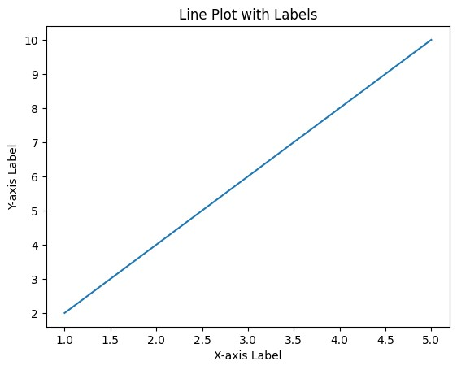

**23.**

import matplotlib.pyplot as plt

x = [1,2,3]

y = [2,4,1]

plt.plot(x, y)

plt.xlabel('x - axis')

plt.ylabel('y - axis')

plt.title('Sample graph!')

plt.show()

**output:**

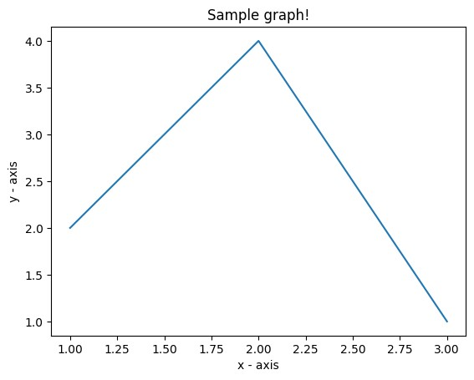

**24.**

import matplotlib.pyplot as plt

import pandas as pd

data = {'date':['2010-03-16','2010-04-16','2010-05-16','2010-06-16','2010-07-16'],

        'open':[774.25, 776.35, 779.49, 779, 779.65],

        'high':[772.09, 775, 778, 774, 777.999],

        'low':[771, 772, 775, 773, 775],

        'close':[772.559998, 776.429993, 776.469971, 776.859985, 775.080017]

}

df= pd.DataFrame(data)

df.set_index('date', inplace=True)

# Plot line chart

plt.figure(figsize=(10, 6))

plt.plot(df.index, df['close'], marker='o', linestyle='-')

plt.title('Alphabet Inc. - Financial Data (Oct 3, 2016 to Oct 7, 2016)')

plt.xlabel('Date')

plt.ylabel('Closing Price')

plt.grid(True)

plt.xticks(rotation=45)

plt.tight_layout()

plt.show()

**output:**

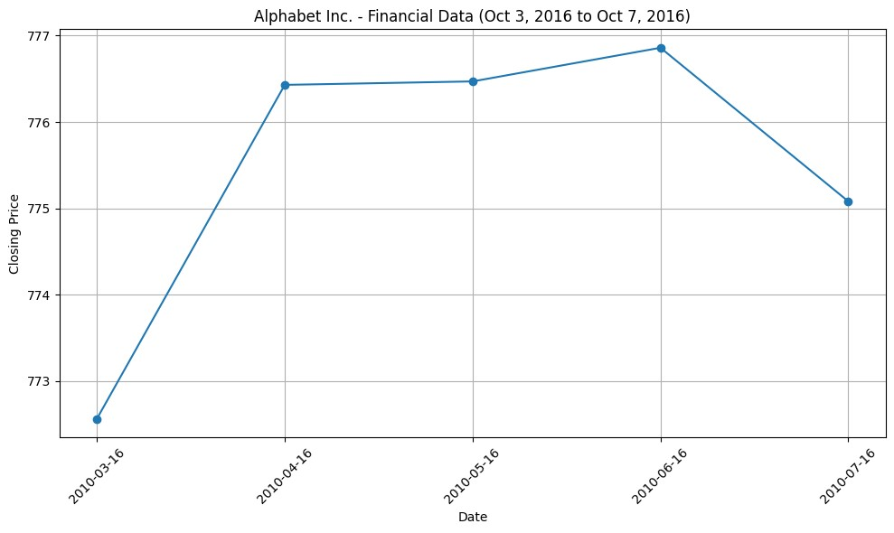

**25.**

import matplotlib.pyplot as plt

x = [1, 2, 3, 4, 5]

y1 = [2, 4, 6, 8, 10]

y2 = [1, 3, 5, 7, 9]

plt.plot(x, y1, label='Line 1', linewidth=2, color='blue')

plt.plot(x, y2, label='Line 2', linewidth=3, color='red')

plt.legend()

plt.xlabel('X-axis Label')

plt.ylabel('Y-axis Label')

plt.title('Multiple Lines Plot')

plt.show()

**output:**

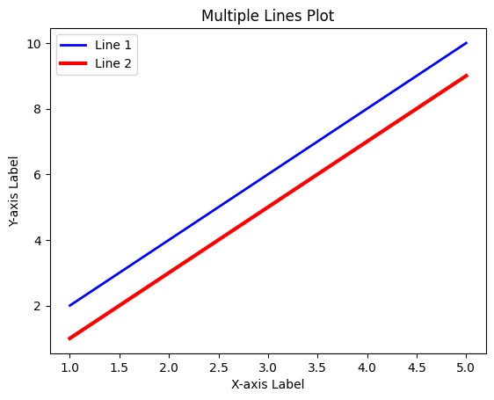

**26.**

import matplotlib.pyplot as plt

import numpy as np

# Generate some sample data

x = np.linspace(0, 10, 100)

y1 = np.sin(x)

y2 = np.cos(x)

y3 = np.tan(x)

fig, axs = plt.subplots(3, 1, figsize=(8, 6))

axs[0].plot(x, y1, color='blue')

axs[0].set_title('Sine Function')

axs[1].plot(x, y2, color='green')

axs[1].set_title('Cosine Function')

axs[2].plot(x, y3, color='red')

axs[2].set_title('Tangent Function')

plt.tight_layout()

plt.show()

**output:**

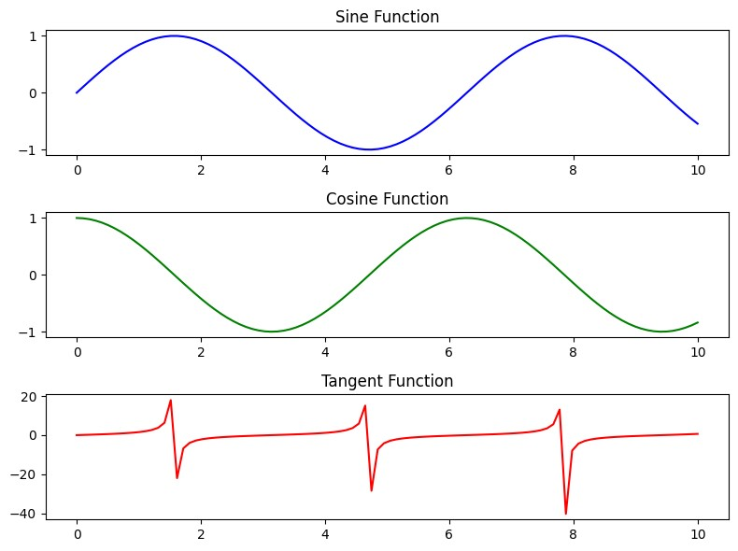

**27.**

import matplotlib.pyplot as plt

# Sample data

languages = ['Java', 'Python', 'PHP', 'JavaScript', 'C#', 'C++']

popularity = [22.2, 17.6, 8.8, 8, 7.7, 6.7]

# Create bar chart

plt.figure(figsize=(10, 6))

plt.bar(languages, popularity, color='skyblue')

# Add labels and title

plt.xlabel('Programming Languages')

plt.ylabel('Popularity (%)')

plt.title('Popularity of Programming Languages')

# Show the plot

plt.xticks(rotation=45)

plt.tight_layout()

plt.show()

**output:**

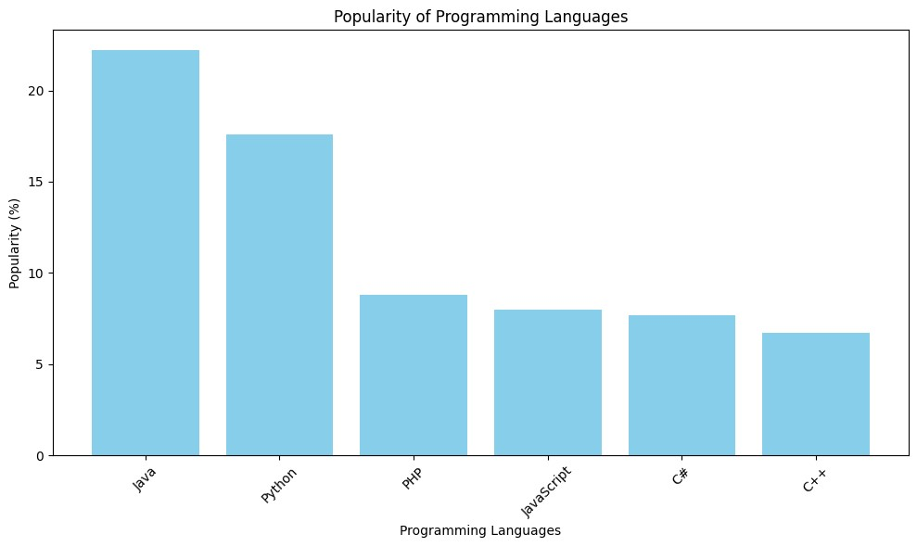

28.

import matplotlib.pyplot as plt

# Sample data

languages = ['Java', 'Python', 'PHP', 'JavaScript', 'C#', 'C++']

popularity = [22.2, 17.6, 8.8, 8, 7.7, 6.7]

# Create horizontal bar chart

plt.figure(figsize=(8, 6))

plt.barh(languages, popularity, color='skyblue')

# Add labels and title

plt.xlabel('Popularity (%)')

plt.ylabel('Programming Languages')

plt.title('Popularity of Programming Languages')

# Show the plot

plt.tight_layout()

plt.show()

output:

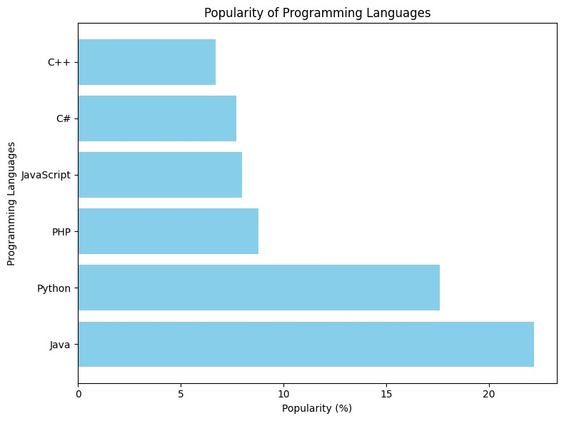

29.

import matplotlib.pyplot as plt

# Sample data

languages = ['Java', 'Python', 'PHP', 'JavaScript', 'C#', 'C++']

popularity = [22.2, 17.6, 8.8, 8, 7.7, 6.7]

# Define colors for each bar

colors = ['blue', 'green', 'red', 'orange', 'purple', 'cyan']

# Create bar chart with different colors

plt.figure(figsize=(10, 6))

plt.bar(languages, popularity, color=colors)

# Add labels and title

plt.xlabel('Programming Languages')

plt.ylabel('Popularity (%)')

plt.title('Popularity of Programming Languages')

# Show the plot

plt.xticks(rotation=45)

plt.tight_layout()

plt.show()

output:

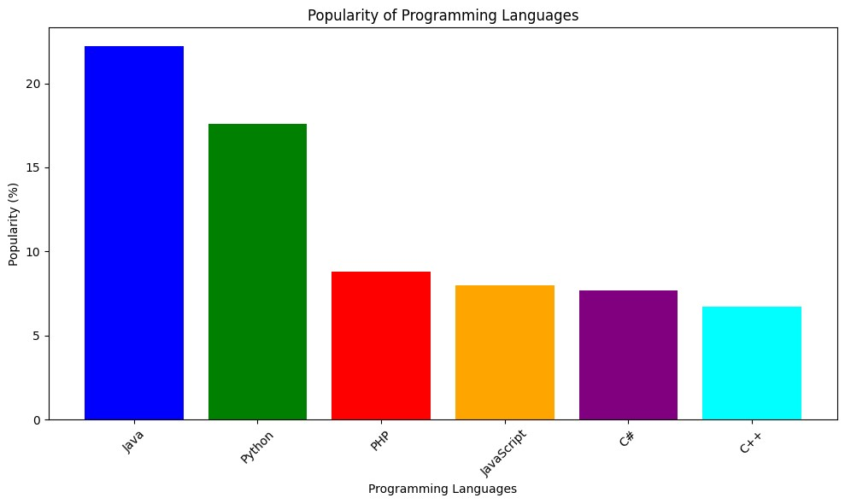

30.

import numpy as np

import matplotlib.pyplot as plt

# Sample data

men_means = (22, 30, 35, 35, 26)

women_means = (25, 32, 30, 35, 29)

# Number of groups

N = len(men_means)

# Width of each bar

width = 0.35

# Indices for the groups

ind = np.arange(N)

# Create bar plot for men

plt.bar(ind, men_means, width, label='Men')

# Create bar plot for women, shift the x-values by the width of the bars

plt.bar(ind + width, women_means, width, label='Women')

# Add labels and title

plt.xlabel('Group')

plt.ylabel('Scores')

plt.title('Scores by Group and Gender')

plt.xticks(ind + width / 2, ('G1', 'G2', 'G3', 'G4', 'G5'))

# Add legend

plt.legend()

# Show the plot

plt.show()

output:

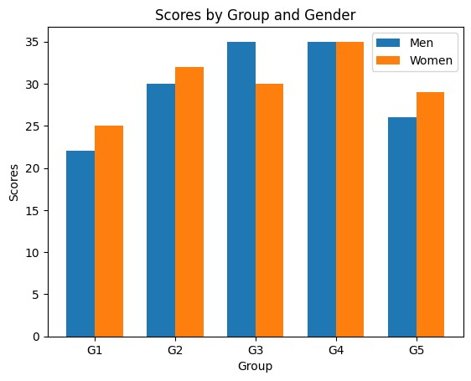

**31.**

import numpy as np

import matplotlib.pyplot as plt

N = 5

menMeans = (22, 30, 35, 35, 26)

womenMeans = (25, 32, 30, 35, 29)

menStd = (4, 3, 4, 1, 5)

womenStd = (3, 5, 2, 3, 3)

ind = np.arange(N)

width = 0.35

p1 = plt.bar(ind, menMeans, width, yerr=menStd, color='red')

p2 = plt.bar(ind, womenMeans, width,

bottom=menMeans, yerr=womenStd, color='green')

plt.ylabel('Scores')

plt.xlabel('Groups')

plt.title('Scores by group\n' + 'and gender')

plt.xticks(ind, ('Group1', 'Group2', 'Group3', 'Group4', 'Group5'))

plt.yticks(np.arange(0, 81, 10))

plt.legend((p1[0], p2[0]), ('Men', 'Women'))

plt.show()

output:

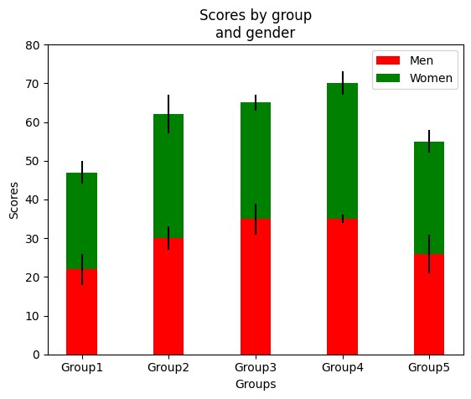

**32**.

import matplotlib.pyplot as plt

import numpy as np

np.random.seed(0)

x = np.random.rand(50)

y = np.random.rand(50)

plt.figure(figsize=(8, 6))

plt.scatter(x, y, color='blue', alpha=0.5)

plt.title('Random Scatter Plot')

plt.xlabel('X')

plt.ylabel('Y')

plt.grid(True)

plt.show()

output:

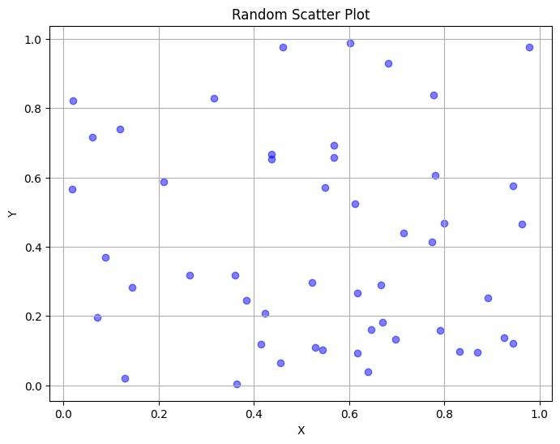

**33**.

import matplotlib.pyplot as plt

import numpy as np

x = np.random.randn(50)

y = np.random.randn(50)

plt.scatter(x, y, s=70, facecolors='none', edgecolors='g')

plt.xlabel("X")

plt.ylabel("Y")

plt.show()

output:

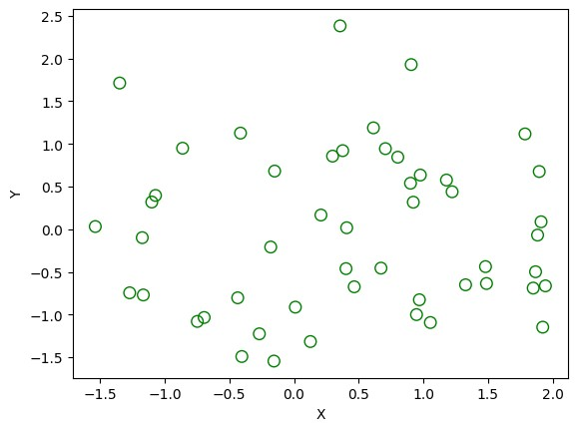

**34**.

import math

import random

import matplotlib.pyplot as plt

no_of_balls = 25

x = [random.triangular() for i in range(no_of_balls)]

y = [random.gauss(0.5, 0.25) for i in range(no_of_balls)]

colors = [random.randint(1, 4) for i in range(no_of_balls)]

areas = [math.pi * random.randint(5, 15)**2 for i in range(no_of_balls)]

plt.figure()

plt.scatter(x, y, s=areas, c=colors, alpha=0.85)

plt.axis([0.0, 1.0, 0.0, 1.0])

plt.xlabel("X")

plt.ylabel("Y")

plt.show()

output;

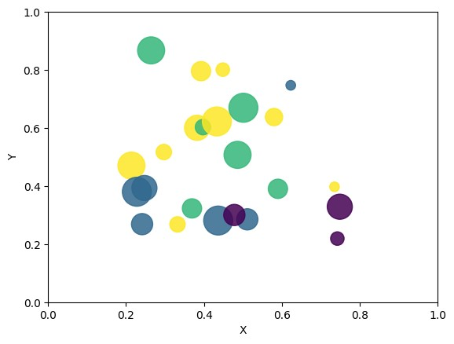

**35**.

import matplotlib.pyplot as plt

import pandas as pd

math_marks = [88, 92, 80, 89, 100, 80, 60, 100, 80, 34]

science_marks = [35, 79, 79, 48, 100, 88, 32, 45, 20, 30]

marks_range = [10, 20, 30, 40, 50, 60, 70, 80, 90, 100]

plt.scatter(marks_range, math_marks, label='Math marks', color='r')

plt.scatter(marks_range, science_marks, label='Science marks', color='g')

plt.title('Scatter Plot')

plt.xlabel('Marks Range')

plt.ylabel('Marks Scored')

plt.legend()

plt.show()

output:

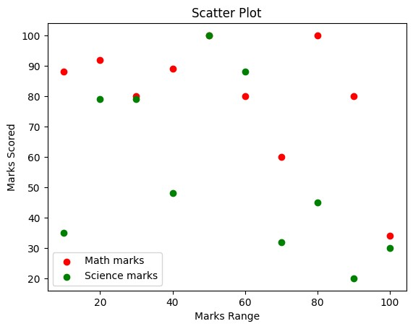

**36.**

import matplotlib.pyplot as plt

import numpy as np

weight1=[67,57.2,59.6,59.64,55.8,61.2,60.45,61,56.23,56]

height1=[101.7,197.6,98.3,125.1,113.7,157.7,136,148.9,125.3,114.9]

weight2=[61.9,64,62.1,64.2,62.3,65.4,62.4,61.4,62.5,63.6]

height2=[152.8,155.3,135.1,125.2,151.3,135,182.2,195.9,165.1,125.1]

weight3=[68.2,67.2,68.4,68.7,71,71.3,70.8,70,71.1,71.7]

height3=[165.8,170.9,192.8,135.4,161.4,136.1,167.1,235.1,181.1,177.3]

weight=np.concatenate((weight1,weight2,weight3))

height=np.concatenate((height1,height2,height3))

plt.scatter(weight, height, marker='*', color=['blue'])

plt.xlabel('weight', fontsize=16)

plt.ylabel('height', fontsize=16)

plt.title('Group wise Weight vs Height scatter plot',fontsize=20)

plt.show()

output:

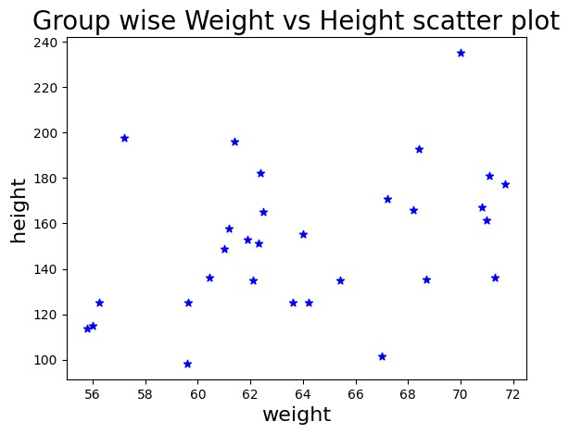

**37.**

import pandas as pd

df = pd.DataFrame({'X':[78,85,96,80,86], 'Y':[84,94,89,83,86],'Z':[86,97,96,72,83]});

print(df)

output:

X Y Z

0 78 84 86

1 85 94 97

2 96 89 96

3 80 83 72

4 86 86 83

**38**.

import pandas as pd

import numpy as np

exam_data = {'name': ['Anastasia', 'Dima', 'Katherine', 'James', 'Emily', 'Michael', 'Matthew', 'Laura', 'Kevin', 'Jonas'],

'score': [12.5, 9, 16.5, np.nan, 9, 20, 14.5, np.nan, 8, 19],

'attempts': [1, 3, 2, 3, 2, 3, 1, 1, 2, 1],

'qualify': ['yes', 'no', 'yes', 'no', 'no', 'yes', 'yes', 'no', 'no', 'yes']}

labels = ['a', 'b', 'c', 'd', 'e', 'f', 'g', 'h', 'i', 'j']

df = pd.DataFrame(exam_data , index=labels)

print(df)

output:

name score attempts qualify

a Anastasia 12.5 1 yes

b Dima 9.0 3 no

c Katherine 16.5 2 yes

d James NaN 3 no

e Emily 9.0 2 no

f Michael 20.0 3 yes

g Matthew 14.5 1 yes

h Laura NaN 1 no

i Kevin 8.0 2 no

j Jonas 19.0 1 yes

39.

import pandas as pd

import numpy as np

exam_data = {'name': ['Anastasia', 'Dima', 'Katherine', 'James', 'Emily', 'Michael', 'Matthew', 'Laura', 'Kevin', 'Jonas'],

'score': [12.5, 9, 16.5, np.nan, 9, 20, 14.5, np.nan, 8, 19],

'attempts': [1, 3, 2, 3, 2, 3, 1, 1, 2, 1],

'qualify': ['yes', 'no', 'yes', 'no', 'no', 'yes', 'yes', 'no', 'no', 'yes']}

labels = ['a', 'b', 'c', 'd', 'e', 'f', 'g', 'h', 'i', 'j']

df = pd.DataFrame(exam_data , index=labels)

print("First three rows of the data frame:")

print(df.iloc[:3])

output:

First three rows of the data frame:

name score attempts qualify

a Anastasia 12.5 1 yes

b Dima 9.0 3 no

c Katherine 16.5 2 yes

addCode

addText

40.

import pandas as pd

import numpy as np

exam_data = {'name': ['Anastasia', 'Dima', 'Katherine', 'James', 'Emily', 'Michael', 'Matthew', 'Laura', 'Kevin', 'Jonas'],

'score': [12.5, 9, 16.5, np.nan, 9, 20, 14.5, np.nan, 8, 19],

'attempts': [1, 3, 2, 3, 2, 3, 1, 1, 2, 1],

'qualify': ['yes', 'no', 'yes', 'no', 'no', 'yes', 'yes', 'no', 'no', 'yes']}

labels = ['a', 'b', 'c', 'd', 'e', 'f', 'g', 'h', 'i', 'j']

df = pd.DataFrame(exam_data , index=labels)

print("Select specific columns:")

print(df[['name', 'score']])

output:

Select specific columns:

name score

a Anastasia 12.5

b Dima 9.0

c Katherine 16.5

d James NaN

e Emily 9.0

f Michael 20.0

g Matthew 14.5

h Laura NaN

i Kevin 8.0

j Jonas 19.0